**Borders and Box Effects**

## 

## CSS Border Properties

**The CSS border properties allow you to specify the style, width, and color of an element's border.**

## Border Style

**The border-style property specifies what kind of border to display.**

**The following values are allowed:**

* **dotted - Defines a dotted border**
* **dashed - Defines a dashed border**
* **solid - Defines a solid border**
* **double - Defines a double border**
* **groove - Defines a 3D grooved border. The effect depends on the border-color value**
* **ridge - Defines a 3D ridged border. The effect depends on the border-color value**
* **inset - Defines a 3D inset border. The effect depends on the border-color value**
* **outset - Defines a 3D outset border. The effect depends on the border-color value**
* **none - Defines no border**
* **hidden - Defines a hidden border**

**The border-style property can have from one to four values (for the top border, right border, bottom border, and the left border).**

### Example

**p.dotted {border-style: dotted;}**

**p.dashed {border-style: dashed;}**

**p.solid {border-style: solid;}**

**p.double {border-style: double;}**

**p.groove {border-style: groove;}**

**p.ridge {border-style: ridge;}**

**p.inset {border-style: inset;}**

**p.outset {border-style: outset;}**

**p.none {border-style: none;}**

**p.hidden {border-style: hidden;}**

**p.mix {border-style: dotted dashed solid double;}**

**Output:**

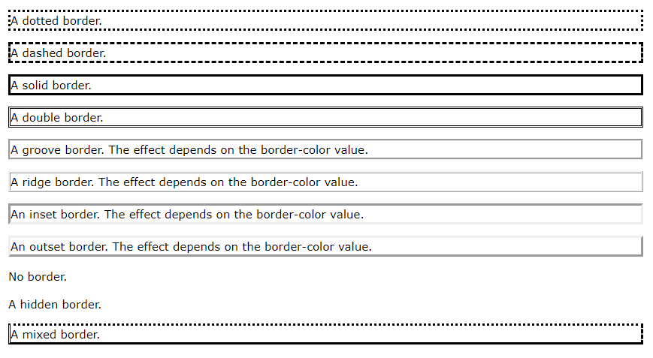

## All CSS Border Properties

|  |  |
| --- | --- |
| **Property** | **Description** |
| [border](https://www.w3schools.com/cssref/pr_border.asp) | Sets all the border properties in one declaration |
| [border-bottom](https://www.w3schools.com/cssref/pr_border-bottom.asp) | Sets all the bottom border properties in one declaration |
| [border-bottom-color](https://www.w3schools.com/cssref/pr_border-bottom_color.asp) | Sets the color of the bottom border |
| [border-bottom-style](https://www.w3schools.com/cssref/pr_border-bottom_style.asp) | Sets the style of the bottom border |
| [border-bottom-width](https://www.w3schools.com/cssref/pr_border-bottom_width.asp) | Sets the width of the bottom border |
| [border-color](https://www.w3schools.com/cssref/pr_border-color.asp) | Sets the color of the four borders |
| [border-left](https://www.w3schools.com/cssref/pr_border-left.asp) | Sets all the left border properties in one declaration |
| [border-left-color](https://www.w3schools.com/cssref/pr_border-left_color.asp) | Sets the color of the left border |
| [border-left-style](https://www.w3schools.com/cssref/pr_border-left_style.asp) | Sets the style of the left border |
| [border-left-width](https://www.w3schools.com/cssref/pr_border-left_width.asp) | Sets the width of the left border |
| [border-radius](https://www.w3schools.com/cssref/css3_pr_border-radius.asp) | Sets all the four border-*-radius properties for rounded corners |
| [border-right](https://www.w3schools.com/cssref/pr_border-right.asp) | Sets all the right border properties in one declaration |
| [border-right-color](https://www.w3schools.com/cssref/pr_border-right_color.asp) | Sets the color of the right border |
| [border-right-style](https://www.w3schools.com/cssref/pr_border-right_style.asp) | Sets the style of the right border |
| [border-right-width](https://www.w3schools.com/cssref/pr_border-right_width.asp) | Sets the width of the right border |
| [border-style](https://www.w3schools.com/cssref/pr_border-style.asp) | Sets the style of the four borders |
| [border-top](https://www.w3schools.com/cssref/pr_border-top.asp) | Sets all the top border properties in one declaration |
| [border-top-color](https://www.w3schools.com/cssref/pr_border-top_color.asp) | Sets the color of the top border |
| [border-top-style](https://www.w3schools.com/cssref/pr_border-top_style.asp) | Sets the style of the top border |
| [border-top-width](https://www.w3schools.com/cssref/pr_border-top_width.asp) | Sets the width of the top border |
| [border-width](https://www.w3schools.com/cssref/pr_border-width.asp) | Sets the width of the four borders |

# border-image Property

**The border-image property allows you to specify an image to be used as the border around an element.**

**The border-image property is a shorthand property for:**

* **[border-image-source](https://www.w3schools.com/cssref/css3_pr_border-image-source.asp)**
* **[border-image-slice](https://www.w3schools.com/cssref/css3_pr_border-image-slice.asp)**
* **[border-image-width](https://www.w3schools.com/cssref/css3_pr_border-image-width.asp)**
* **[border-image-outset](https://www.w3schools.com/cssref/css3_pr_border-image-outset.asp)**
* **[border-image-repeat](https://www.w3schools.com/cssref/css3_pr_border-image-repeat.asp)**

**Syntax**

**border-image: *source slice width outset repeat*|initial|inherit;**

## Property Values

|  |  |
| --- | --- |
| **Value** | **Description** |
| *border-image-source* | The path to the image to be used as a border |
| *border-image-slice* | How to slice the border image |
| *border-image-width* | The width of the border image |
| *border-image-outset* | The amount by which the border image area extends beyond the border box |
| *border-image-repeat* | Whether the border image should be repeated, rounded or stretched |
| initial | Sets this property to its default value. |
| inherit | Inherits this property from its parent element. |

# 

# border-image-outset Property

**The border-image-outset property specifies the amount by which the border image area extends beyond the border box.**

**Tip: Also look at the** [**border-image**](https://www.w3schools.com/cssref/css3_pr_border-image.asp) **property (a shorthand property for setting all the border-image-* properties).**

## CSS Syntax

**border-image-outset: *length*|*number*|initial|inherit;**

**Note: The border-image-outset property can take from one to four values (top, right, bottom, and left sides). If the fourth value is omitted, it is the same as the second. If the third one is also omitted, it is the same as the first. If the second one is also omitted, it is the same as the first.**

## Property Values

|  |  |
| --- | --- |
| **Value** | **Description** |
| *length* | A length unit specifying how far from the edges the border-image will appear. Default value is 0 |
| *number* | Represent multiples of the corresponding border-width |
| initial | [Sets this property to its default value. Read about initial](https://www.w3schools.com/cssref/css_initial.asp) |
| inherit | [Inherits this property from its parent element. Read about inherit](https://www.w3schools.com/cssref/css_inherit.asp) |

# border-image-repeat Property

### 

### The border-image-repeat property specifies whether the border image should be repeated, rounded or stretched.

### **Tip:** Also look at the [border-image](https://www.w3schools.com/cssref/css3_pr_border-image.asp) property (a shorthand property for setting all the border-image-* properties).

### 

### Example

**#borderimg {**

**border-image-source: url(border.png);**

**border-image-repeat: repeat;**

**}**